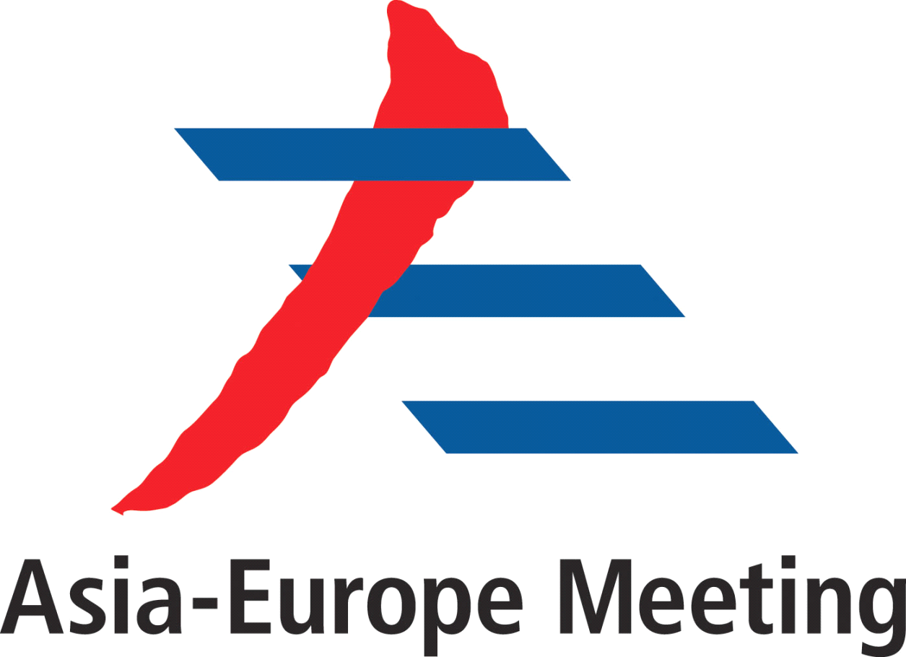

ASEM Think-Tank Symposium
Connectivity: Opportunity to Boost ASEM Cooperation
Chair's Summary Statement
22-23 July, 2014, Shanghai, China

The ASEM Think-Tank Symposium on Connectivity: Opportunity to Boost ASEM Cooperation, co-sponsored by China, European Union, Mongolia, Poland and Singapore, was held in Shanghai, China on 22-23 July 2014 under the auspices of the Shanghai Institutes for International Studies. Some sixty participants from 28 ASEM members shared their knowledge, experiences and visions，discussed various aspects of ASEM cooperation on connectivity and have come up with the following ideas and suggestions:

It is visionary for ASEM leaders to stress at the 9th ASEM summit the importance of strengthening regional connectivity to support economic integration in Asia and Europe. Efforts to enhance connectivity in ASEM and by its members are among major determinants of the successful stories of the social and economic development in both Asia and Europe.

At a time of growing globalization, ASEM is at a crossroad. While maintaining a balance among its three pillars of cooperation, more emphasis should be put on economic pillar to increase its relevance and vitality through more pragmatic cooperation with tangible results. It is high time for connectivity to be incorporated as a priority area of cooperation in ASEM as it is poised to catalyze cooperation in broader areas and reshape landscape of ASEM space.

ASEM connectivity implies smoother policy communication, improved road connectivity, unimpeded trade, unrestricted flow of capital for investment and better understanding between people, etc. Effective connectivity depends on the quality of both hard infrastructure such as transport infrastructure, energy pathways, logistics networks, and information and communications technology infrastructure, and soft infrastructure such as policies, strategies, customs procedures, regulatory systems, personnel and institutional capacities building and transboundary cooperation.

The diversity of ASEM members in terms of development levels, historical and cultural background, population densities and national capacities presents huge potential as well as serious challenges for pushing forward ASEM connectivity. While members’ comparative advantages constitute incentives for cooperation, a sound balance should be reached between national strategies and regional priorities, bearing in mind the practical difficulties and challenges, such as security concerns, that may arise at the ground level.

In order to deliver results, strong political wills and concerted efforts are required of members and relevant stakeholders. Different concerns should be appropriately addressed and common ground should be found to forge joint action. The process should be open, inclusive and beneficial to all.

To promote cooperation on connectivity, a regional strategy and a mechanism such as a working group within ASEM would be needed, taking on board all relevant intra-Asia regional and sub-regional connectivity initiatives. ASEM members are also encouraged to form area-specific core groups to cooperate on voluntary basis. Expanded partnership with regional, international organizations and private sectors is necessary to mobilize sufficient resources. It is particularly important to engage industries and businesses, including the small and medium sized enterprises. The proposed industry dialogue on connectivity is welcome and the idea of creating an ASEM Infrastructure Investment Bank could also be explored.

It was recommended to reconvene the ASEM Economic Ministers' Meeting as soon as possible and convene the Transportation Ministers' Meeting on a regular basis to build consensus, enhance coordination and identify eligible areas for cooperation. Other immediate steps could include enhancing the role of ASEM Business Forum; upgrading ASEM Trade Facilitation Action Plan and Investment Promotion Action Plan; simplifying visa application process of businessmen and tourists and intensifying people-to-people communication etc.

ASEM connectivity will only be possible with real and practical action. ASEM members are encouraged to come up with and actively participate in creative initiatives, and seek to develop synergies between them. Initiatives such as the Master Plan on ASEAN Connectivity, Silk Road Economic Belt and 21st Century Maritime Silk Road are supported as their implementation will contribute to narrowing development gap among ASEM members and further enhance links between Asia and Europe. It is also useful to exchange best practices, relating for example to the EU single market.

Think-tanks can play a more active role in ASEM in enhancing connectivity. They could provide strategic visions and suggestions on such issues as how to increase ASEM’s relevance in the new international political and economic landscape and how to map out the future direction of ASEM in the lead-up to its 20th anniversary in 2016, and help identify priority areas for cooperation. Partnership between ASEM think-tanks needs to be further enhanced through intensified networking, joint research, scholarship exchanges and study results sharing, etc. The critical role played by media - both traditional and new social media - in encouraging enhanced Asia-Europe connectivity was highlighted.

The participants recommended the Summary being presented to the upcoming ASEM Senior Officials’ Meeting and the 10th ASEM Summit for consideration.

The participants expressed their appreciation to China for successfully hosting the symposium, and thanked European Union, Mongolia, Poland and Singapore for co-sponsoring the event.

